2023 ACSM CEC Certificate

**­­­­­­­­­­­­­­­____________ ____________**

*Participant Name*

**New England Chapter of the American College of Sports Medicine**

*Organization*

**"Back to the Future: Forging Future Horizons through History”**

*Course Title*

**October 12 and 13, 2023**

**MassMutual Center, Springfield, MA**

*Date and Location*

**650388 13**

*Approved Provider Number*  *CECs Awarded*

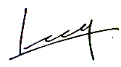

*Chee-Hoi Leong, PhD*

*Program Chairperson*